Aging and Disability Resource Connection of Placer County
Advisory Committee Meeting Minutes
August 28, 2026 2:00 – 3:30 PM
Zoom Link:
https://us02web.zoom.us/rec/share/i-zvkiJ3PpD9v3GOSaWo3r5kNdLvsCy8amfuwS5iVieTPD8cdPp87SbQco9x56Xe.JCGtwSHLpXislpsL
Passcode: rz6%Vv68

Attendees: Anson Houghton, German Ayon, Naola Johnson, Liz Pazdral (AAA4) Elizabeth Pope (PIRS) Michelle Nevins (Del Oro), Anna Berry (Seniors First), Colby Hytoff (Placer County Adult System of Care), William Reed, (AAA4 Governing Board, Placer County Older Adult Advisory Commission), Deborah Tyler (HICAP Services of Northern California), Lorraine Calong-Haimson, Carl Jones, (Placer County IHSS Advisory Committee) Julie Avendano (Placer County APS), Jill Blake (Partnership Health Plan), Cassidy Paganucci, (Placer County District Attorney's Office / Placer Protects Elder Abuse Team), Erica Williamson, (Placer County Public Health), Kristine Alcamo (Engage Services)

2. Review of Previous Minutes: Minutes from April 28, 2026, were reviewed and accepted as presented.

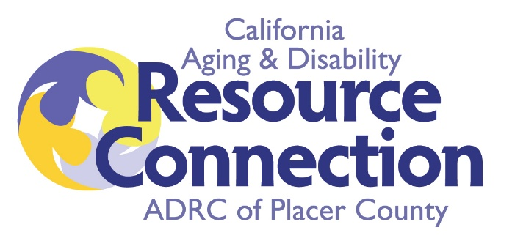
3. ADRC Annual Reporting Preview and Partner Discussion: Liz described the annual reporting process to the California Department of Aging and reviewed some of the accomplishments of the past year. Excerpts from the narrative and data are appended/attached to these minutes.

4. Cross Training: Deborah Tyler, Regional Coordinator for HICAP, provided a detailed presentation regarding Medicare education, open enrollment, fraud prevention, and support services available through the Health Insurance Counseling and Advocacy Program. She provided training regarding how service providers can prepare for the open enrollment beginning in October as well as the changes expected with the implementation of federal law H.R. 1 in 2027. Her slides are appended/attached to these minutes.

5. Agency Updates
Del Oro Caregiver Resource Center (Michelle Nevins) Michelle Nevins reported that Del Oro Caregiver Resource Center is participating in the federal GUIDE program, a free Medicare program that covers the costs of dementia care navigation services for those who are eligible, through a contract with Tembo and is providing GUIDE services for both existing and new clients. Debbie Tyler indicated interest in learning more about the program as referrals and inquiries increase.

Auburn Senior Health Fair
Deborah Tyler announced the Auburn Senior Health Fair expected in October and invited ADRC participation. The ADRC expressed interest in having a resource table at the event.

Medi-Cal Long-Term Care Concerns
Naola raised questions regarding emerging reports about Medi-Cal changes affecting individuals living in residential care settings and those at risk of homelessness due to exhaustion of personal funds. Deborah noted that information is still evolving and committed to sharing updates as additional guidance becomes available.

Announcements
- Next Steering Committee Meeting: August 25
- Next ADRC Advisory Committee Meeting: October 27

